

Lab No:01 Date:2082/09/13
Title: Creating two or more tables and insert/update some of the values showing both DDL and DML commands. Ensure to have primary Keys/Foreign Keys in the result.
This task demonstrates the use of DDL and DML commands in Oracle SQL to create and manage relational database tables. Multiple tables are created with Primary Key and Foreign Key constraints to maintain data integrity. Data insertion and updates are performed to show how relationships between tables are enforced in a database system. Create type is used to create a user-defined data type in Oracle. It let group related data (attributes) into one object, just like a class in Object-Oriented Programming.
The error occurred because the SQL commands were executed in the wrong Oracle container.
PDB$SEED is a read-only pluggable database, so DDL commands like CREATE TABLE are not allowed there.
Oracle XE uses a multitenant architecture, where user objects must be created inside a writable PDB.
Switching the session to XEPDB1 resolved the issue and allowed table creation successfully.
SHOW CON_NAME; show_pdbs;
1. DDL (Table Creation)
- Two tables DEPARTMENTS and EMPLOYEES were created using CREATE TABLE.
- dept_id and emp_id were defined as Primary Keys.
- A Foreign Key was created in EMPLOYEES (dept_id) referencing DEPARTMENTS(dept_id).
- This established a parent–child relationship between the table.

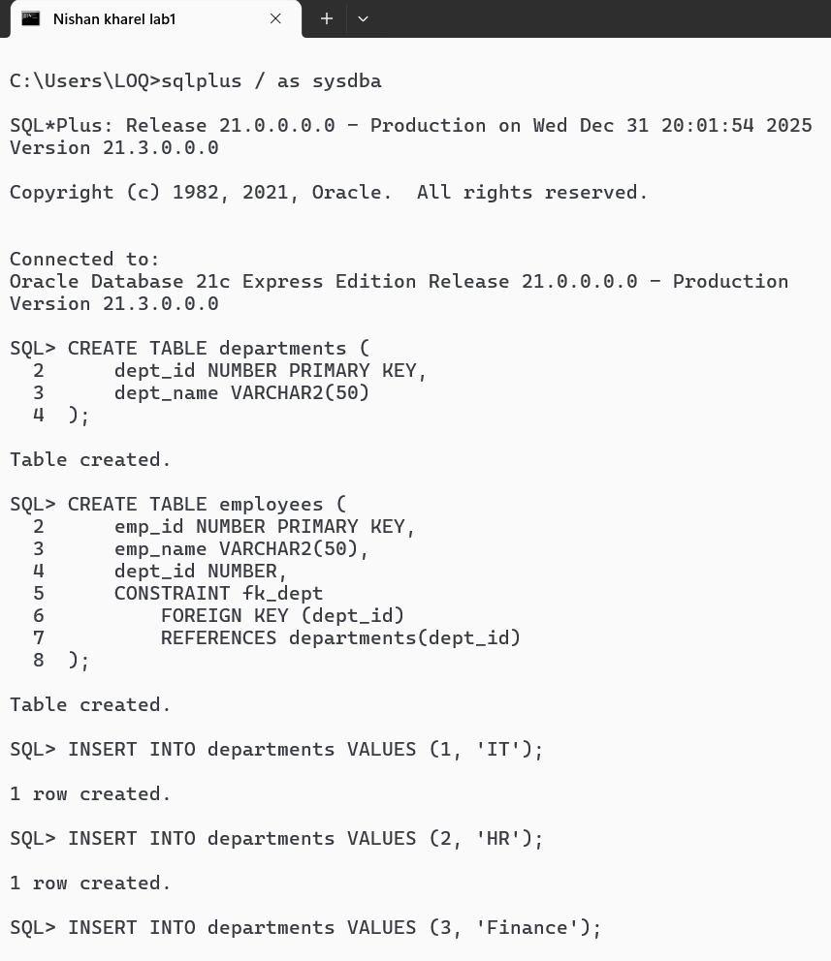
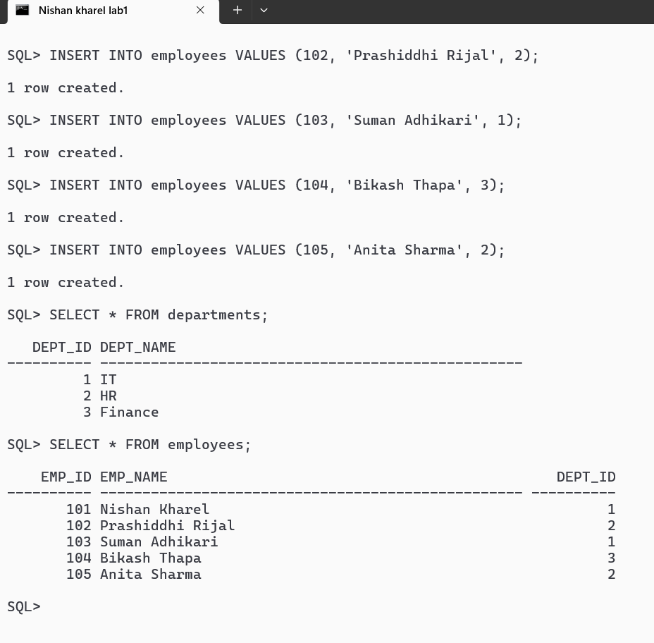

Subquery: A subquery in Oracle SQL is a SELECT statement nested inside another SQL statement (e.g., SELECT, INSERT, UPDATE, or DELETE). The inner query executes first, and its result is then used by the outer (parent) query for filtering, comparison, or as a temporary table.
Display employees who work in the IT department.
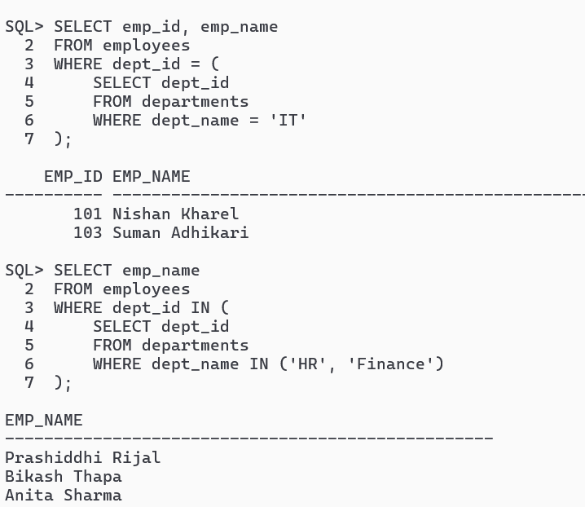
Group By: The GROUP BY clause in Oracle SQL is used to group rows that have the same values in specified columns into a set of summary rows, typically used in conjunction with aggregate functions like COUNT(), SUM(), AVG(), MAX(), and MIN().
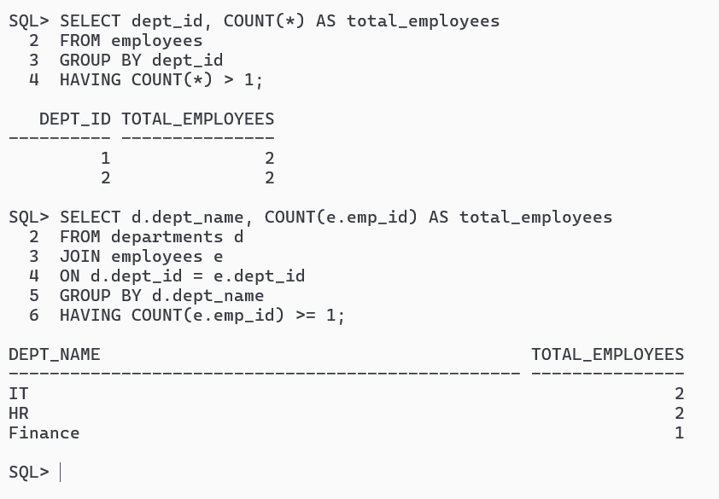

A View is a virtual table based on the result-set of an SQL statement, which can be queried just like a regular table but does not physically store data. You can interact with views using SQL queries through interfaces like SQL Developer or SQL*Plus.
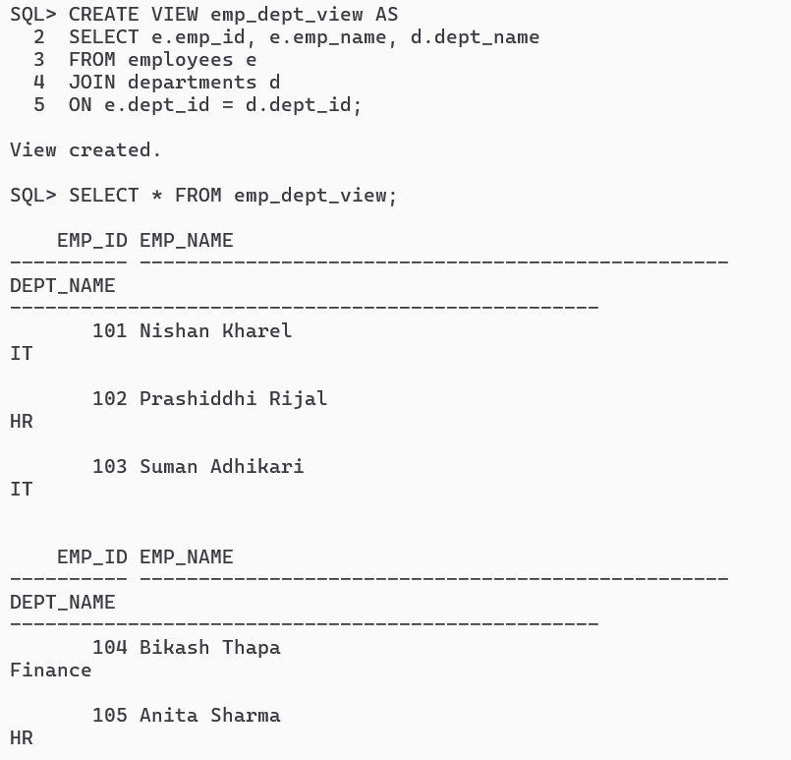

A window function performs calculations across a set of rows related to the current row. It does not reduce the number of rows (unlike GROUP BY). It uses the OVER() clause.
Basic syntax: analytic_function() OVER (
PARTITION BY column
ORDER BY column
)
Count employees in each department (without grouping):

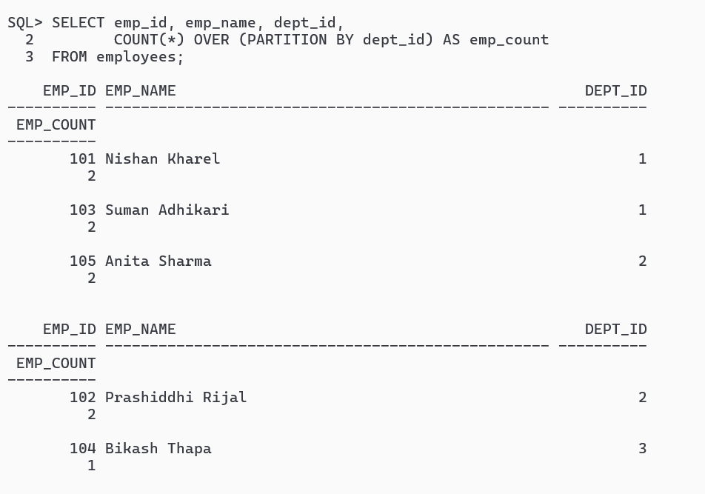

RANK() – With Possible Gaps
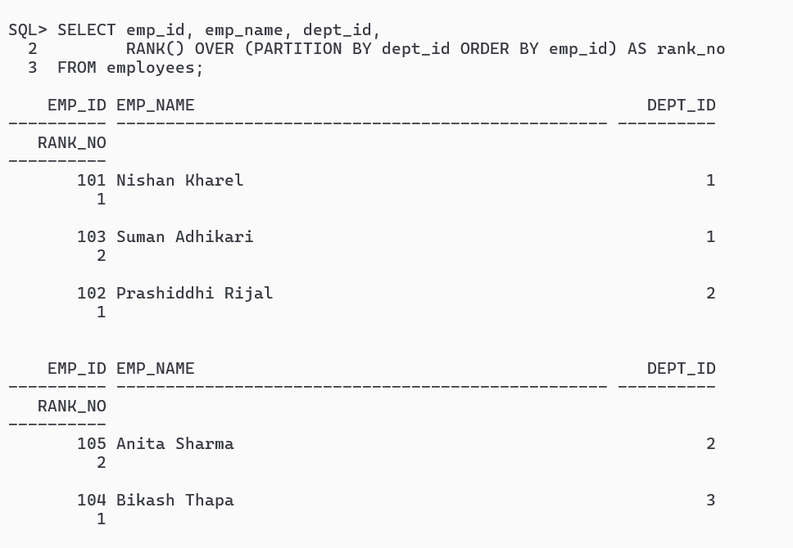
Common Table Expression (CTE) is a temporary result set defined within a SQL statement using the WITH clause. It improves readability and can be referenced multiple times within the same SELECT, INSERT, UPDATE, or DELETE statement.
Show all employees with their department name:

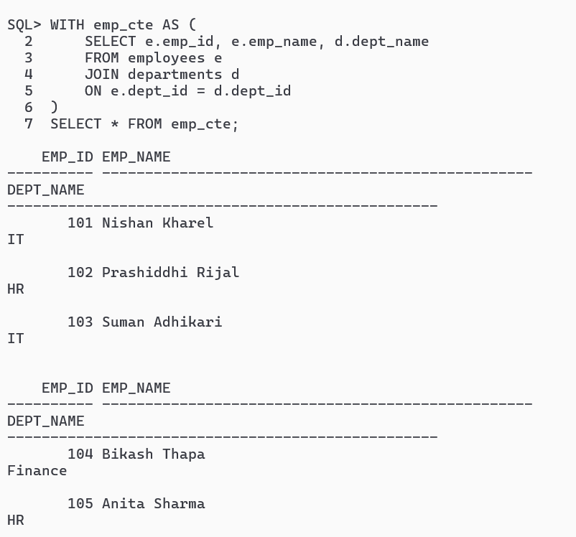
A Materialized View is a database object that stores the result of a query physically.
Employees with Department Names:
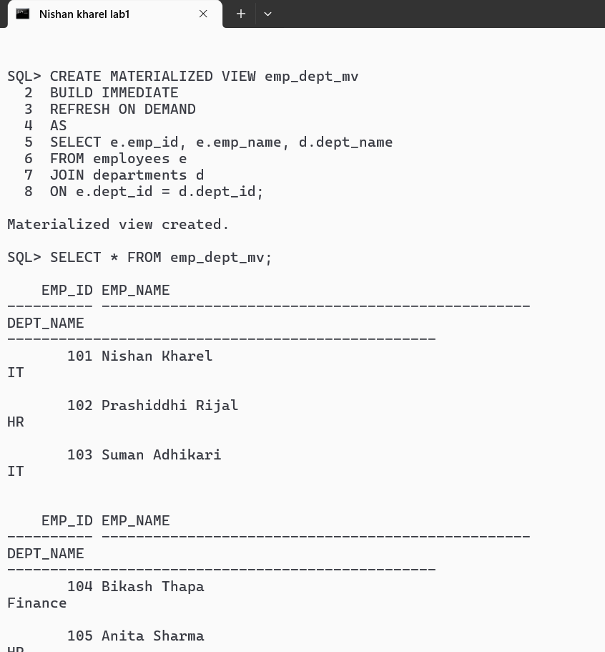

NNER JOIN (Equi Join): Returns rows that have matching values in both tables.
Most commonly used join. Rows without a match in either table are not included.
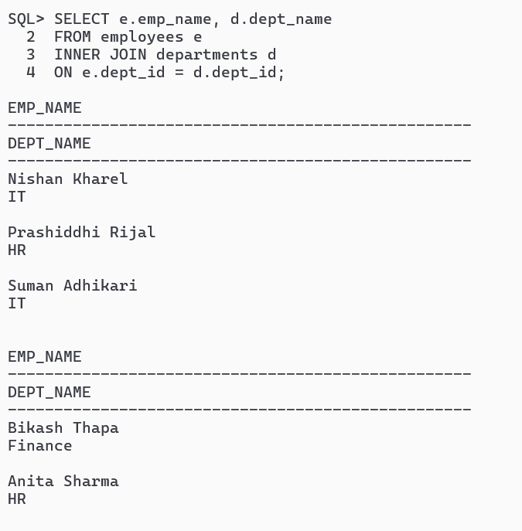
LEFT OUTER JOIN (LEFT JOIN): returns all rows from the left table (employees) and matching rows from the right table (departments).
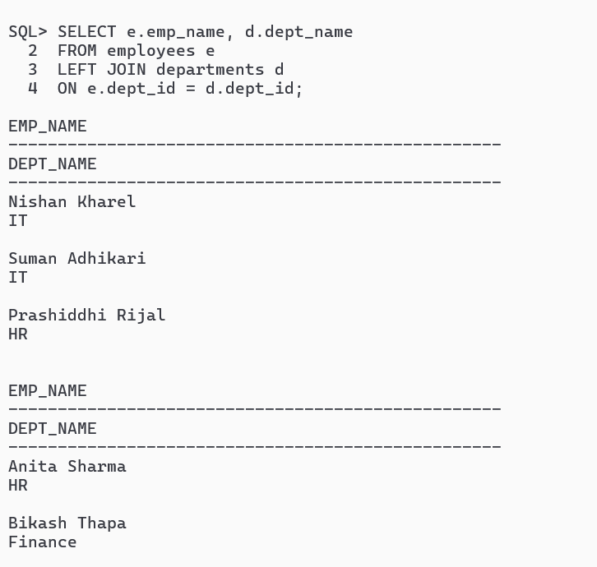

RIGHT OUTER JOIN (RIGHT JOIN): Returns all rows from the right table (departments) and matching rows from the left table (employees).
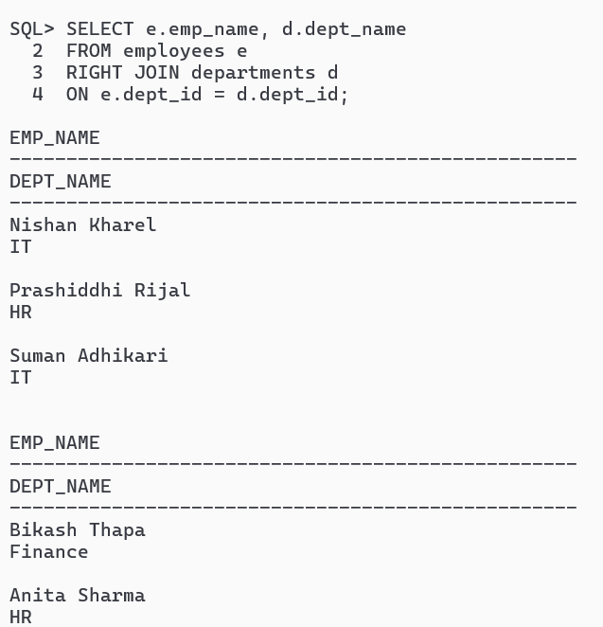
FULL OUTER JOIN (FULL JOIN): Returns all rows from both tables.
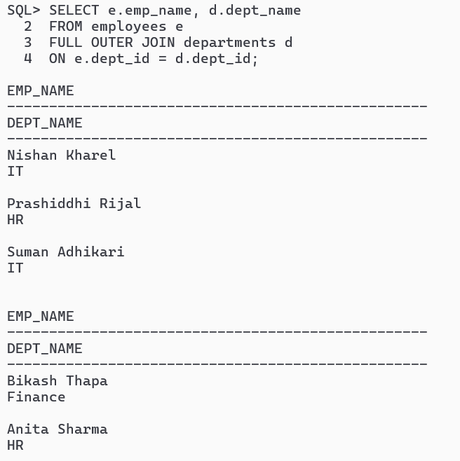

CROSS JOIN (Cartesian Product): Returns all combinations of rows from both tables.
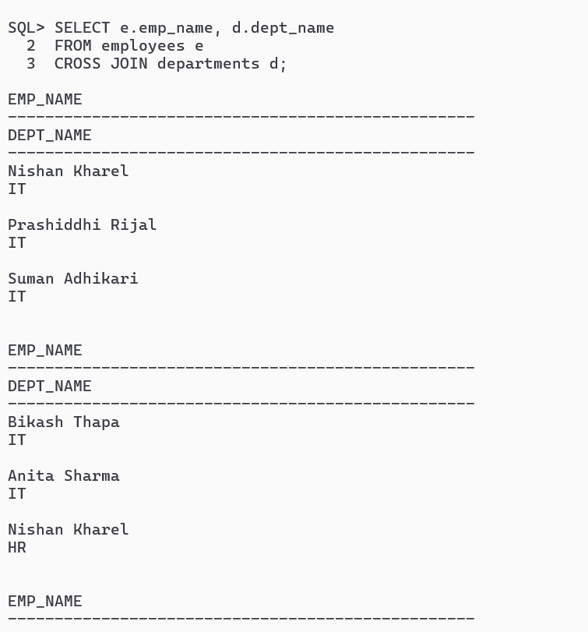
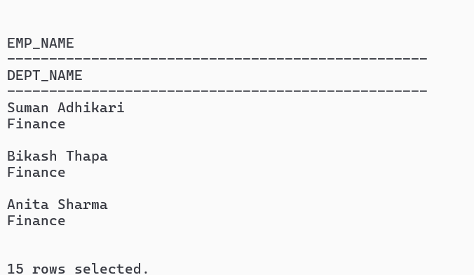

SELF JOIN: A table is joined with itself.
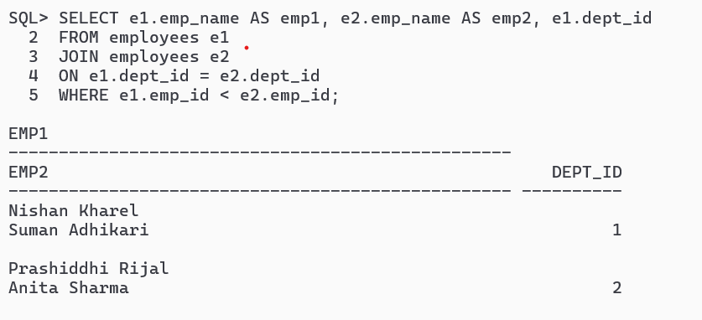

USING Clause (Simplified Join):
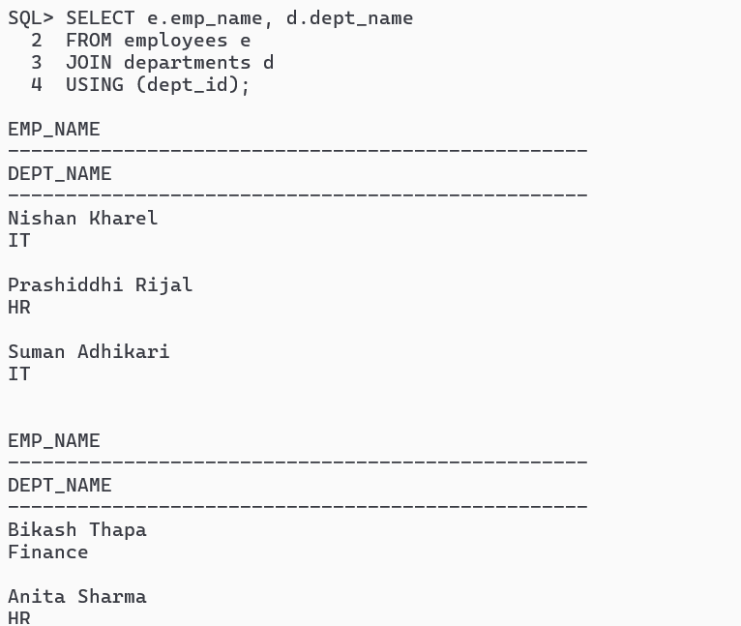

A stored procedure is a named PL/SQL block stored in the database. Can be called multiple times without rewriting the code. Helps in reusability, modularity, and security.
CREATE OR REPLACE PROCEDURE procedure_name
(
parameter1 IN datatype, -- input
parameter2 OUT datatype, -- output
parameter3 IN OUT datatype -- input/output
)
IS
BEGIN
-- SQL statements / PL/SQL code
END procedure_name;
/
Simple Procedure (No Parameters):

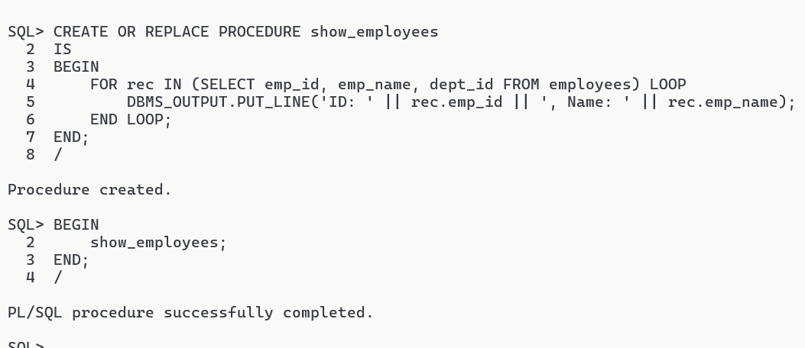

Procedure with IN Parameter:
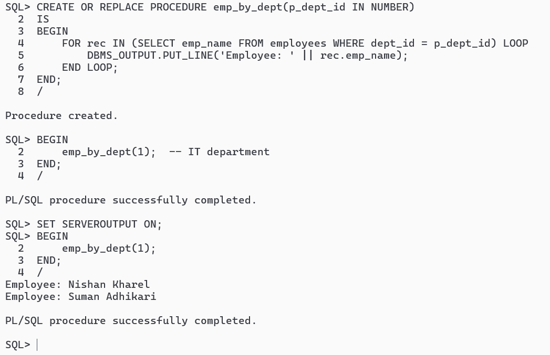
Hence, OracleSQL*Plus or SQL Developer, when you use DBMS_OUTPUT.PUT_LINE, the output does not automatically show unless DBMS_OUTPUT is enabled. Stored procedures are precompiled PL/SQL blocks stored in the database that allow for reusability and modular programming. They can accept IN, OUT, and IN OUT parameters to process input values, return results, or both, making them flexible for various database operations. By using stored procedures, database operations become more efficient, secure, and easier to maintain, and their output can be viewed using DBMS_OUTPUT or returned through OUT parameters.

